Project Planning Template
ServiceNow Incident Lifecycle Automation

1. Project Information
Field | Details
Project name | Incident Lifecycle Automation in ServiceNow

2. Project Overview

2.1 Problem statement
Describe the current incident handling problems (manual routing, missed SLAs, repeated incidents, scattered knowledge).

2.2 Objectives
- Automate the incident lifecycle from creation to resolution using workflows.
- Integrate Knowledge Management for faster resolution.
- Integrate Change Management to control fixes and reduce recurring incidents.
- Improve overall IT service efficiency.

2.3 Scope
In scope | Out of scope
Incident lifecycle, Business Rules, Flow Designer, notifications, SLAs, Knowledge and Change integration | Unapproved external integrations and production deployment are excluded unless agreed

3. Requirements
ID | Requirement | Priority | Status
R1 | Auto-calculate priority from impact and urgency | High | Planned
R2 | Auto-assign by category and subcategory | High | Planned
R3 | SLA tracking with warning and breach alerts | High | Planned
R4 | Knowledge suggestion and article capture | Medium | Planned
R5 | Raise and link Change Requests from incidents | Medium | Planned

4. Work Breakdown and Schedule
# | Task | Start | End | Owner
1 | Requirements and lifecycle design | To be scheduled | To be scheduled | Project team — to be assigned
2 | Core configuration (forms, groups, SLAs) | To be scheduled | To be scheduled | Project team — to be assigned
3 | Business Rules | To be scheduled | To be scheduled | Project team — to be assigned
4 | Flow Designer flows | To be scheduled | To be scheduled | Project team — to be assigned
5 | Knowledge Management integration | To be scheduled | To be scheduled | Project team — to be assigned
6 | Change Management integration | To be scheduled | To be scheduled | Project team — to be assigned
7 | Testing and UAT | To be scheduled | To be scheduled | Project team — to be assigned
8 | Deployment and documentation | To be scheduled | To be scheduled | Project team — to be assigned

5. Solution Design
Component | Planned design
Incident states | New, In Progress, On Hold, Resolved, Closed, Canceled
Business Rules | Configure states, validation, assignment, notifications, and SLA rules in ServiceNow
Flows | Configure states, validation, assignment, notifications, and SLA rules in ServiceNow
Notifications | Configure states, validation, assignment, notifications, and SLA rules in ServiceNow
SLA definitions | Configure states, validation, assignment, notifications, and SLA rules in ServiceNow
Knowledge integration | Configure states, validation, assignment, notifications, and SLA rules in ServiceNow
Change integration | Configure states, validation, assignment, notifications, and SLA rules in ServiceNow
Reports / dashboards | Configure states, validation, assignment, notifications, and SLA rules in ServiceNow

6. Resources and Tools
- ServiceNow Personal Developer Instance (or project instance)
- Flow Designer, Business Rules, Notifications, SLA Definitions
- Knowledge Management and Change Management applications
- Update sets for moving configuration between instances

7. Risks and Mitigation
# | Risk | Level | Mitigation
1 | Requirements change during development | Medium | Confirm scope in writing; use change control
2 | Flows conflict with existing Business Rules | Medium | Document order of execution; test end to end
3 | Low Knowledge article adoption | Medium | Prompt on resolution; track usage
4 | Incomplete requirements or configuration errors | Medium | Review requirements, test in a non-production instance, and obtain stakeholder sign-off

8. Testing Plan
# | Test case | Expected result | Status
1 | Create incident with impact and urgency | Priority set correctly | Not run
2 | Resolve without resolution notes | Blocked with a message | Not run
3 | Put On Hold without a reason | Blocked with a message | Not run
4 | Raise Change Request from incident | Incident linked and On Hold | Not run
5 | Resolve and create Knowledge article | Article created in draft | Not run
6 | SLA breach scenario | Escalation notification sent | Not run

9. Success Criteria
- MTTR reduced against baseline:
- SLA compliance target:
- Incidents resolved with a Knowledge article:
- Reduction in recurring incidents:

10. Approval
Name | Role | Signature | Date

Process Diagram
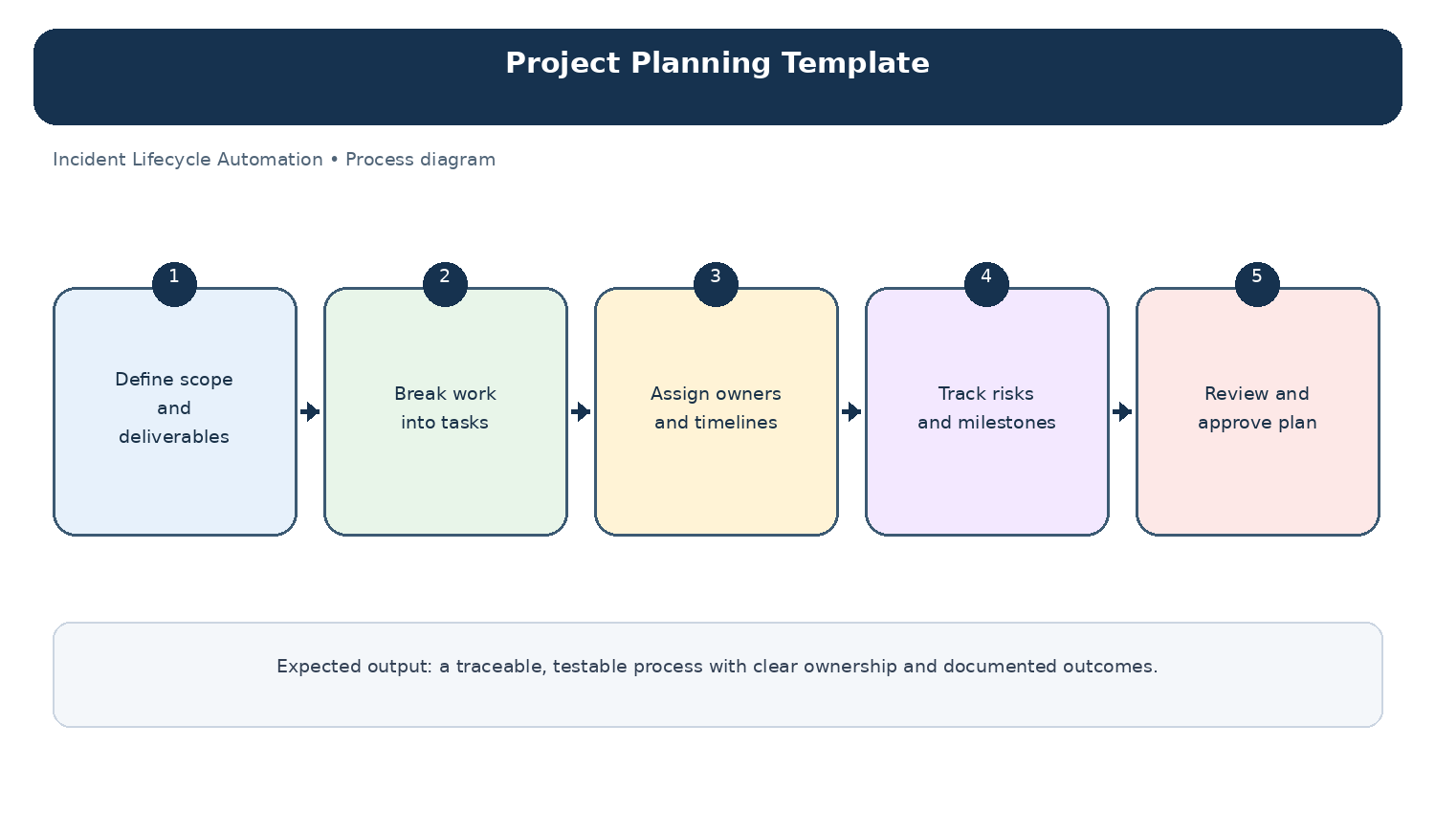
Diagram: Project Planning Template — project-specific process overview.

